Contents

Spring boot with Docker 2

Stop docker process 10

Remove docker image 10

Install maven on Windows 11

# 

# Spring boot with Docker

1. Go to <https://start.spring.io/> create simple project and download it.  
   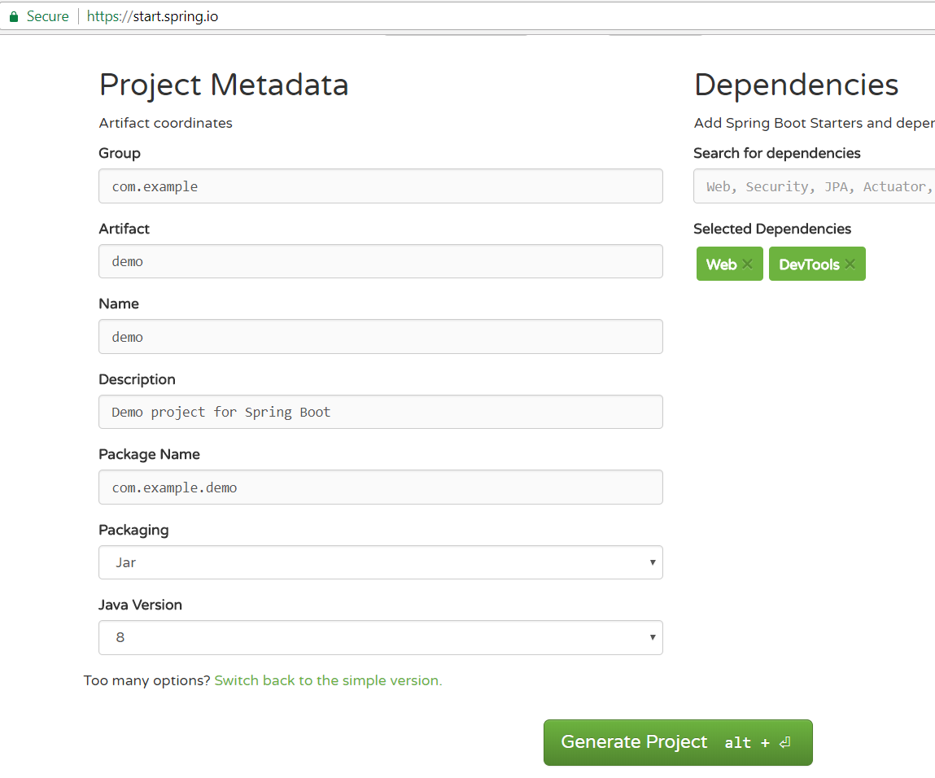
2. Unzip into your workspace.  
   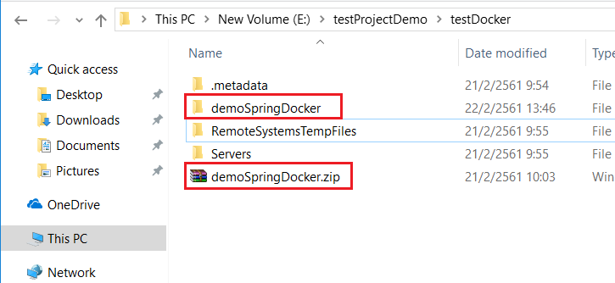
3. Right click on package explorer >> select import …  
   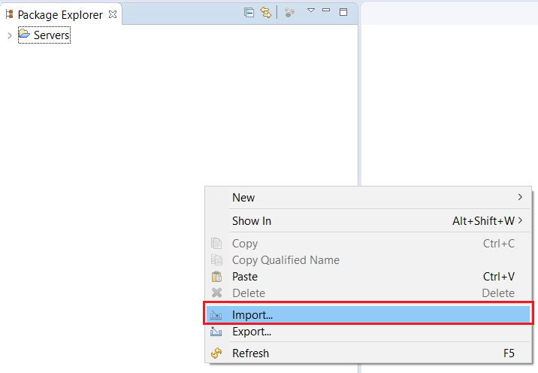  
   choose import project from folder or archive  
   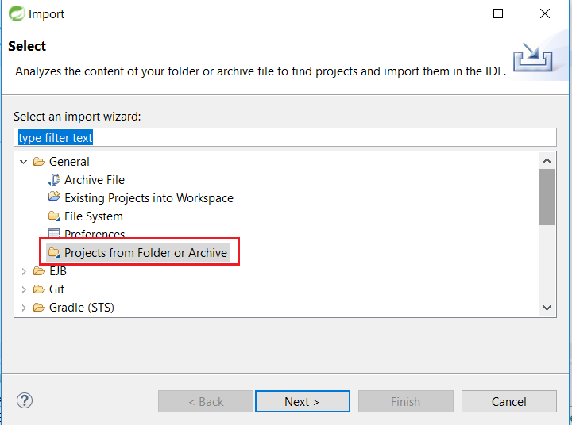  
     
     
   select location of your project which unzip from step 2 and wait for ide to import project for a while.  
   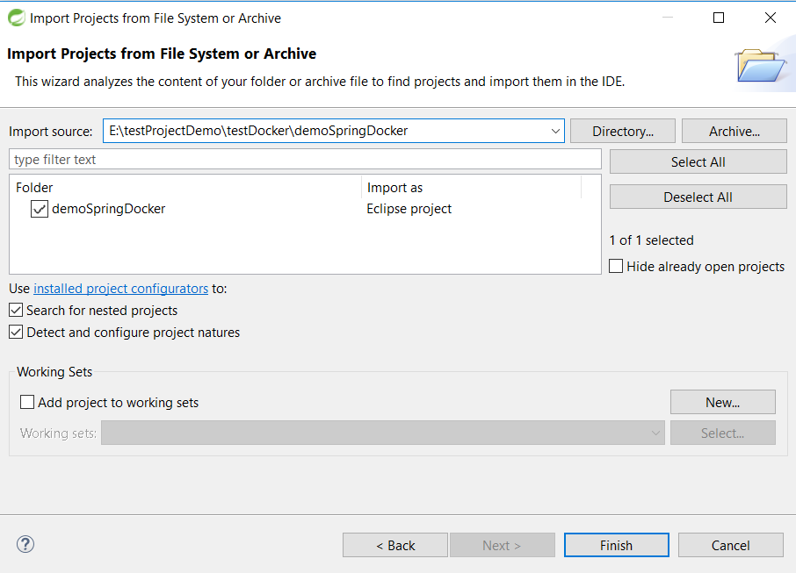
4. Now create simple controller and start spring boot app to test if it working correctly.  
   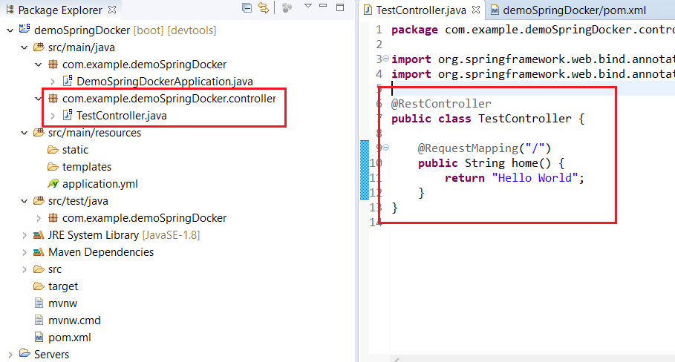  
     
     
     
     
   right click on project name >> select Run As >> choose Spring Boot App  
   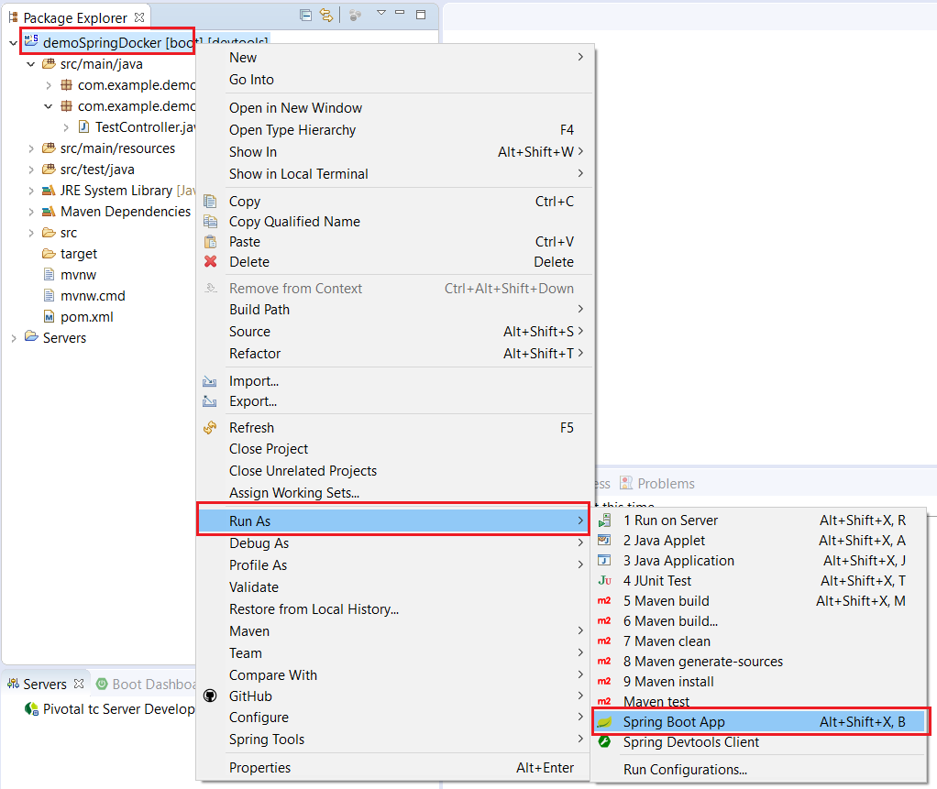  
   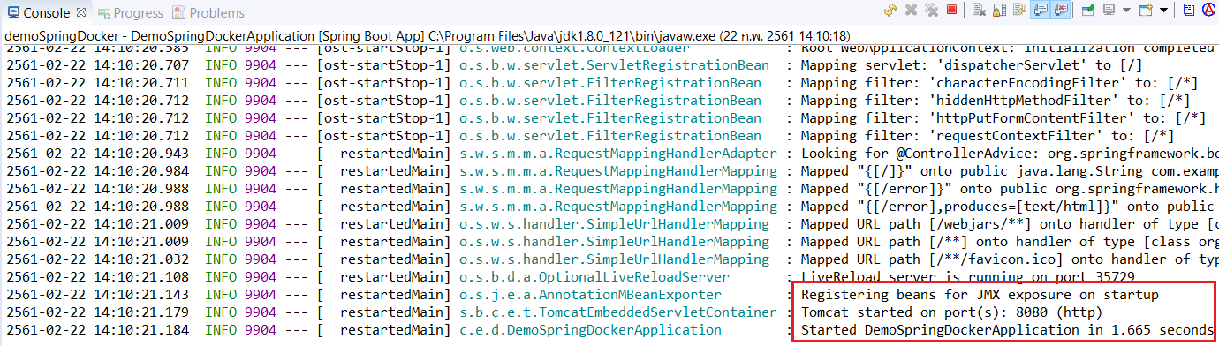  
     
     
     
     
     
     
     
     
     
   now go to http://localhost:8080/ and see the result  
     
   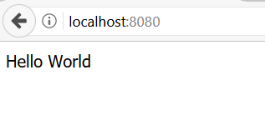
5. Now create **Dockerfile** and add content as below:  
     
     
     
     
     
     
     
   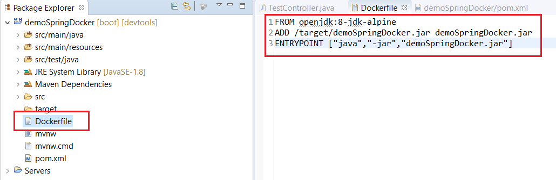

FROM openjdk:8-jdk-alpine

ADD /target/demoSpringDocker.jar demoSpringDocker.jar

ENTRYPOINT ["java","-jar","demoSpringDocker.jar"]

1. Final name **demoSpringDocker** will be used in **Dockerfile** for jar reference  
   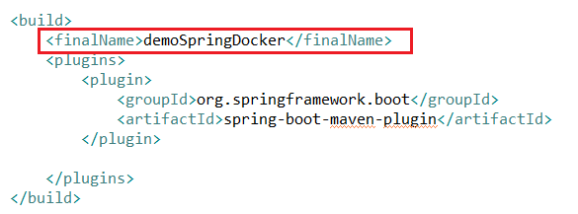
2. Now open powershell we going to use docker command to build docker image  
   cd to your project location  
   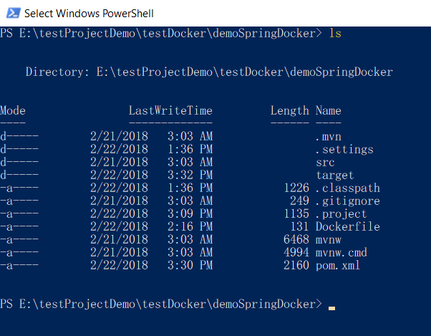
3. Clean your project using **mvn clean**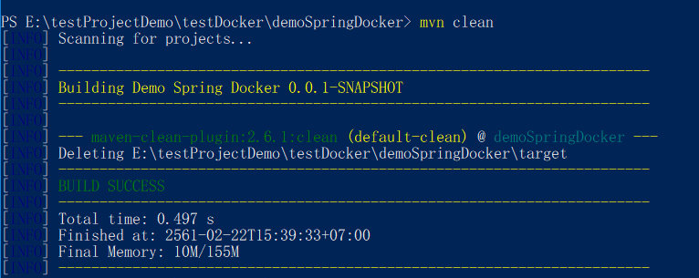  
   next   
   **mvn install**  
   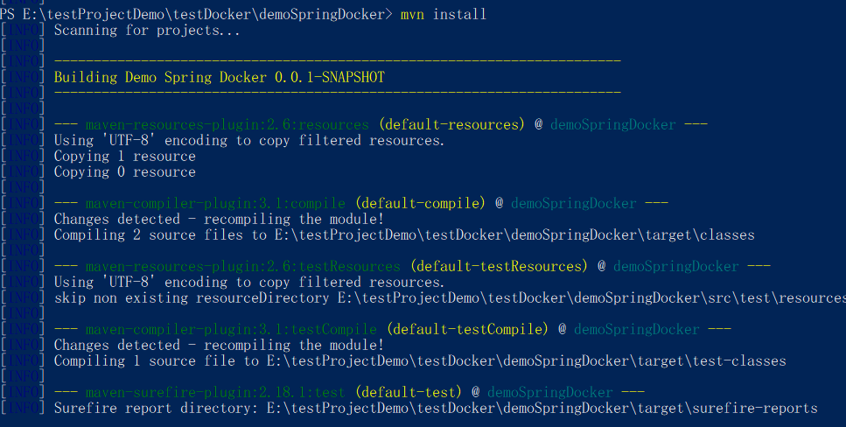
4. If you try command **docker images** you will see only one docker image from previous lesson  
   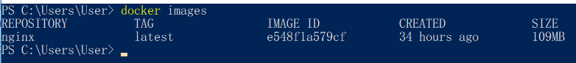
5. Now try **docker build -f <Dockerfile> -t <docker image name> "."** to build docker image  
     
   -f <Dockerfile>: reference to location of Dockerfile which you create on step 5  
   -t <docker image name>: this is name of your docker image  
   **\*\*\*\*at the end of command don’t forget “.”**  
     
   Complete command >>   
   **docker build -f Dockerfile -t springdocker .**  
     
   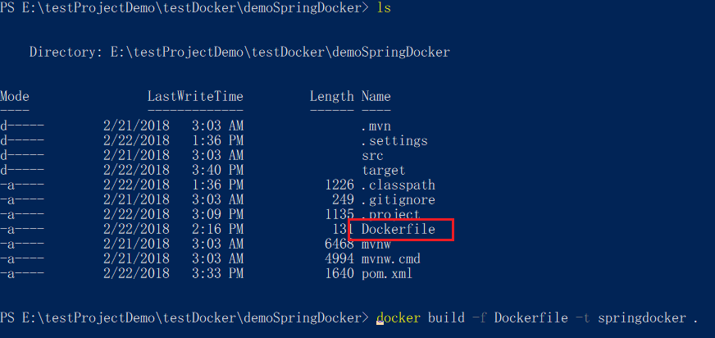  
   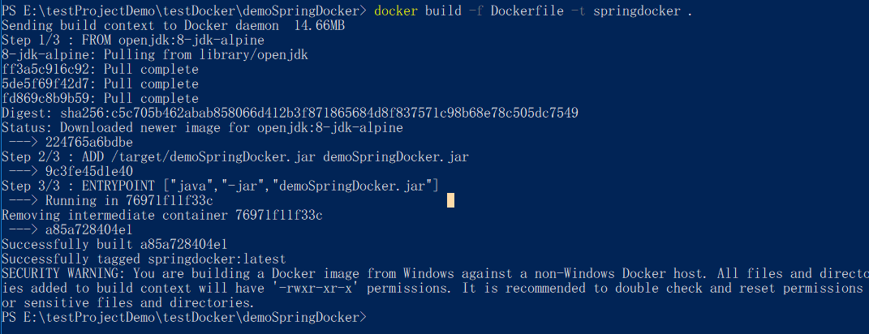
6. After build done try **docker images** and check the result  
     
   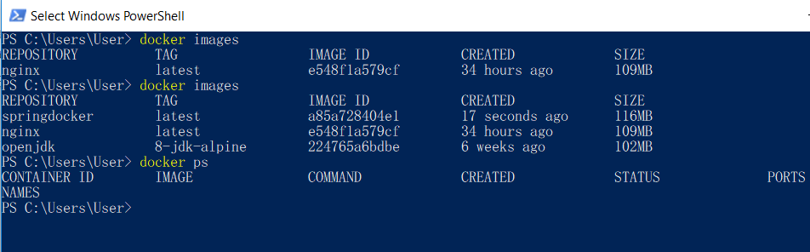
7. Now try command docker run and don’t forget to add docker image name which created from step 10  
     
   complete command >> **docker run –d –p 8080:8080 springdocker**  
     
   **docker ps** to check process  
     
   if you didn’t use --name docker will set it for you as picture below:  
   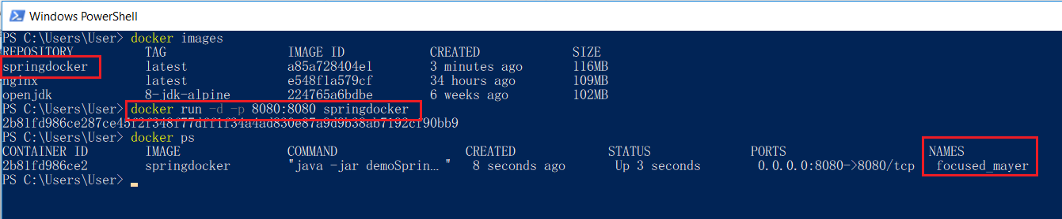
8. Now try http://localhost:8080/ and see the result.  
     
   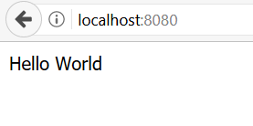

# **Stop docker process**

If you want to stop process you can use command >> **docker stop <process id>**  
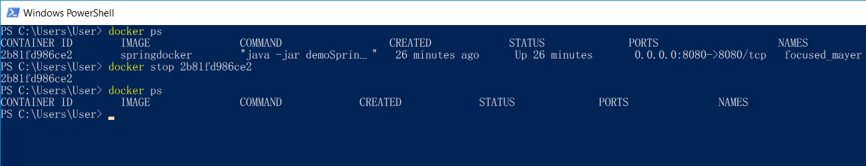

Remove docker image  
you can’t remove images unless you remove container   
first try this command to check all process >> **docker ps -a**  
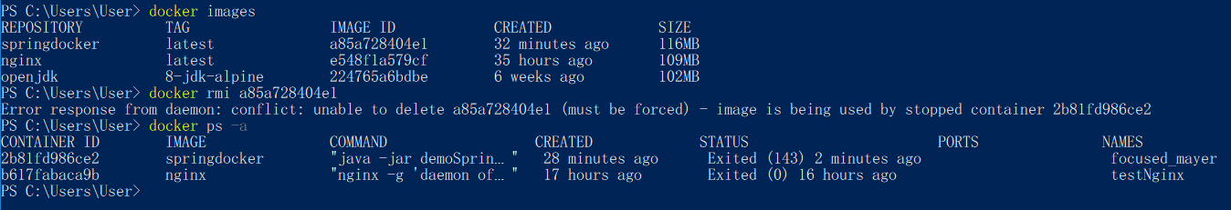 **docker rm <container id>** to remove container  
then you can use **docker rmi <image id>** to remove docker image already  
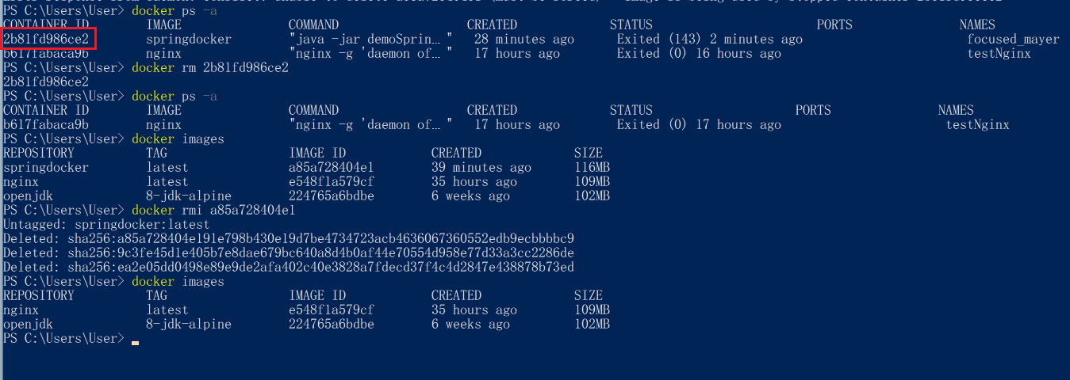

Install maven on Windows

1. Download apache maven from this link >> <http://maven.apache.org/download.cgi>  
   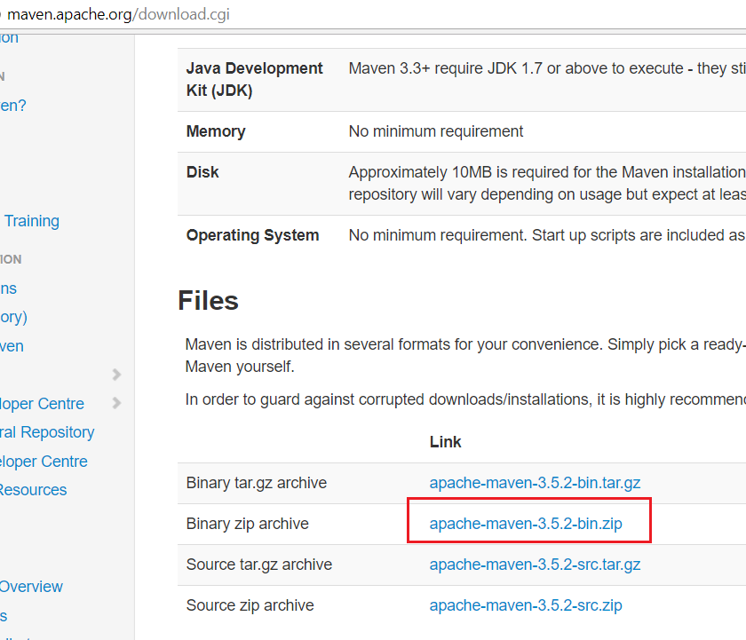
2. Unzip your file.  
   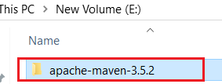
3. Add **M2_HOME** and **MAVEN_HOME** in environment variable.  
   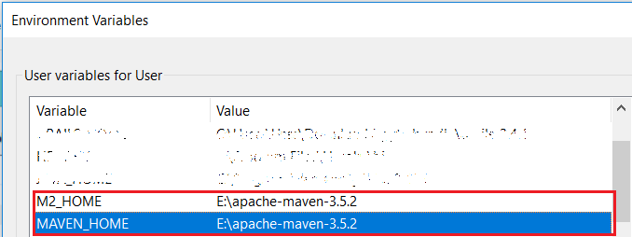  
     
     
     
     
     
     
     
     
     
   add **M2_HOME** to your path  
   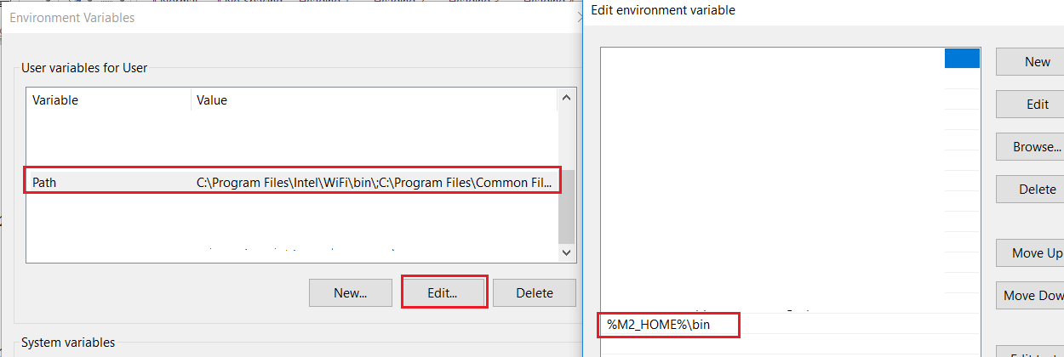
4. Now try **mvn –version** on your powershell and see the result.  
   